**AWS Route53 DNS Failover**

In Active Passive scenario of sites you need to change the DNS pointing to secondary site in case primary site is down We can automate this DNS changing process in AWS Route53 DNS service.

**To automate this process**

1. We need to set health monitoring parameters for each site to monitor the health status of sites.
2. Need to add DNS entries of site pointing to each site. (eg primary & secondary)
3. Configure the DNS route policy to do the failover in case primary site is down based on health check status.

**Configuration**

Example Scenario:

Domain Name: demo.com

Web site: [www.demo.com](http://www.demo.com)

Primary site: site1.demo.com

Secondary site: site2.demo.com

Health check on port 443 for both the sites(primary & secondary)

Steps:

1. Login to AWS🡪 route53🡪 Hosted zone (create a new zone or chose existing)
2. Create Host “A” records for primary & secondary site.

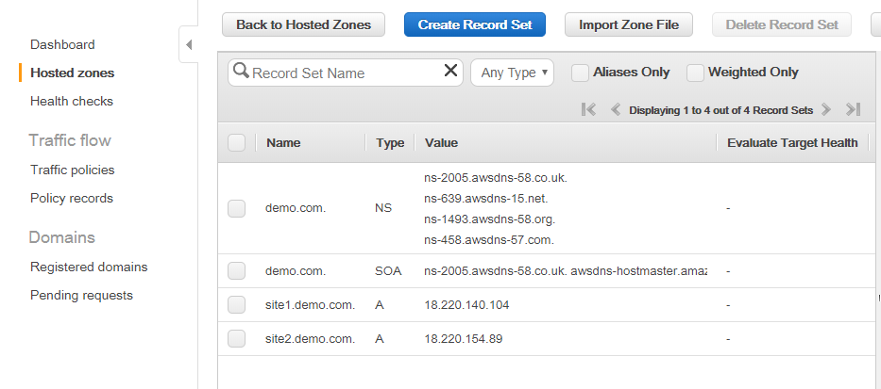

1. Go to health check and create Health check.

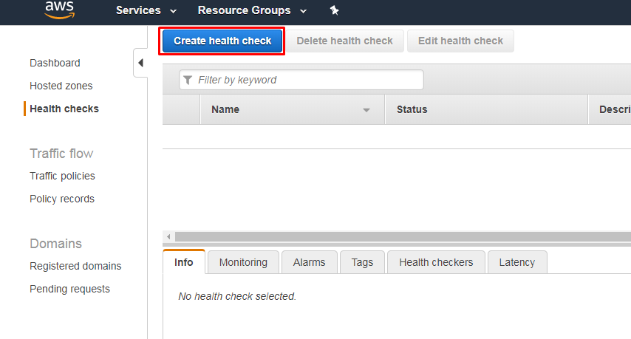

1. Configure Health check to monitor health of Primary site. Example given in image below.

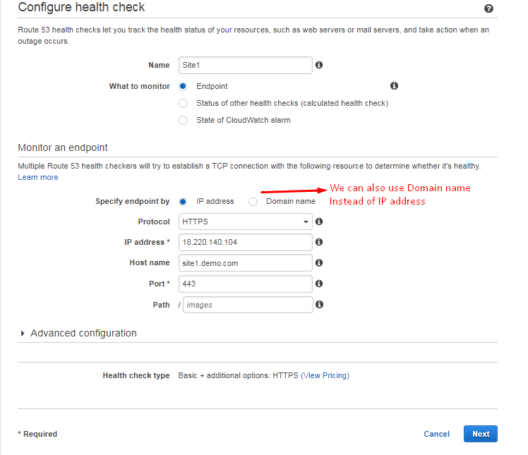

1. Check the health monitor

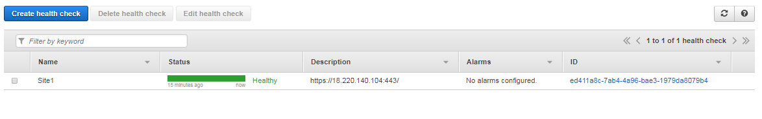

1. Configure Health check to monitor health of Secondary site. Example given in image below.

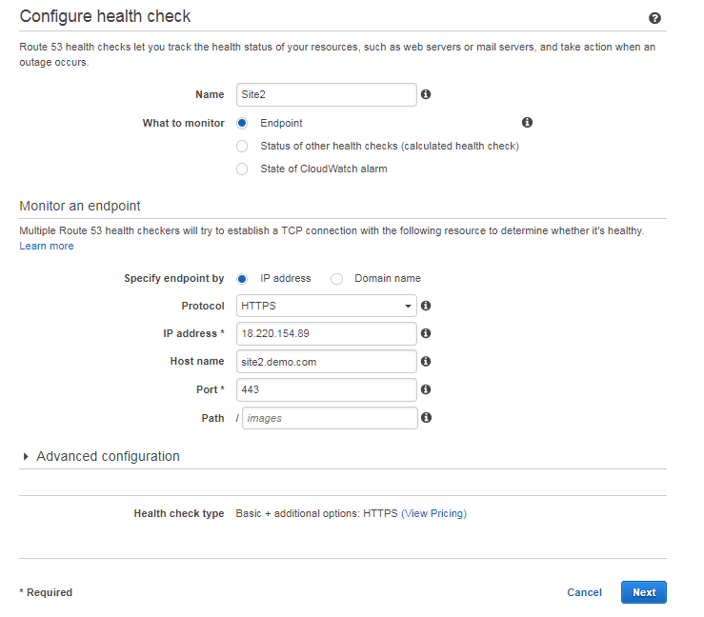

1. Verify both the health monitor

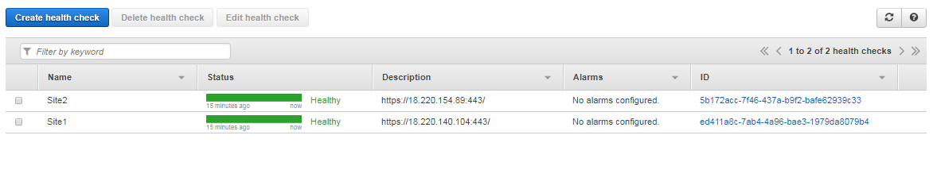

1. Go to hosted Zone



1. Create a CNAME record for [www.demo.com](http://www.demo.com) pointing to primary site. (you can also create “A” record instead of CNAME if using IP address instead of Domain name), select routing policy “Failover”, record type primary , associate with health check “yes” and select health check associate for primary site. Example given in below image

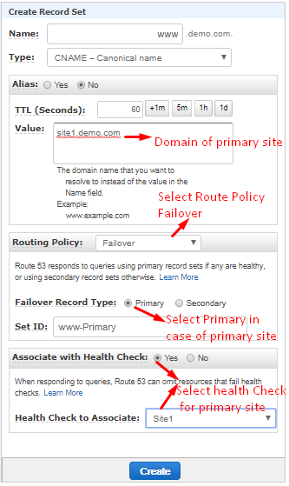

1. Create a CNAME record for [www.demo.com](http://www.demo.com) pointing to Secondary site. (you can also create “A” record instead of CNAME if using IP address instead of Domain name), select routing policy “Failover”, record type Secondary , associate with health check “yes” and select health check associate for secondary site. Example given in below image

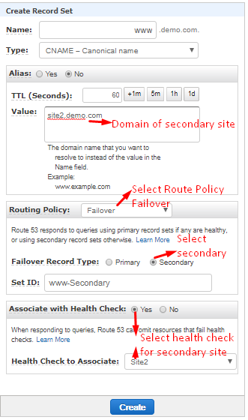

1. Verify the CNAME records created.

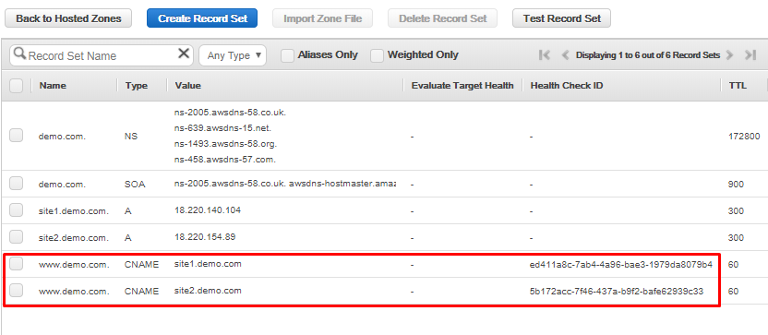

1. Validate the failover by taking down primary site and browsing the site [www.demo.com](http://www.demo.com).